**Experiment 1:**  Implement all techniques of Black Box-Testing, White Box Testing taking your Mini Project as the Context System.

**Q.1) What is Software Testing?**

Software testing is a process, to evaluate the functionality of a software application with an intent to find whether the developed software met the specified requirements or not and to identify the defects to ensure that the product is defect-free to produce a quality product.

**There are different methods that can be used for software testing.**

**[1] Black-Box Testing**

The technique of testing without having any knowledge of the interior workings of the application is called black-box testing. The tester is oblivious to the system architecture and does not have access to the source code. Typically, while performing a black-box test, a tester will interact with the system's user interface by providing inputs and examining outputs without knowing how and where the inputs are worked upon.

**Types of Black Box Testing:**

1. Functional Testing:

Functional testing is performed using the functional specification provided by the client and verifies the system against the functional requirements. For an instance we can consider User Registration, User Login, Add/Delete or Modify flight information for Airway reservation system project that all the functionality is correctly working

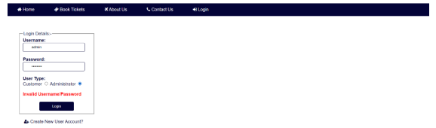

*Functional Testing for Login Function*

1. Non-functional testing:

Non-Functional testing checks the Performance, reliability, scalability and other non-functional aspects of the software system. For an Example we can consider your database whether it is scalable when we required. The figure below shows the capacity of database

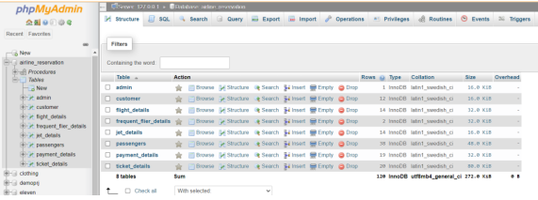

1. Regression Testing

The Regression Testing is generally done whenever modifications are made to the source code of a project. The Regression Testing can also be defined as the process of testing changes made to the computer program and also makes sure that the older programming still works with the new changes. So, before any new version of a software product is released, the old test cases for the project will be run against the software with the changes made, to make sure that the old functionalities of the project still work.

*Adding New Flight - Regression testing*

**[2] White Box Testing**

White Box Testing is a software testing method in which the internal structure/design/implementation of the item being tested is known to the tester. Implementation and impact of the code are tested.

**Types of White Box Testing:**

1. Path Testing

Path Testing is a method that is used to design the test cases. In path testing method, the control flow graph of a program is designed to find a set of linearly independent paths of execution. In this method Cyclomatic Complexity is used to determine the number of linearly independent paths and then test cases are generated for each path. As mentioned in the figure

1. Loop Testing

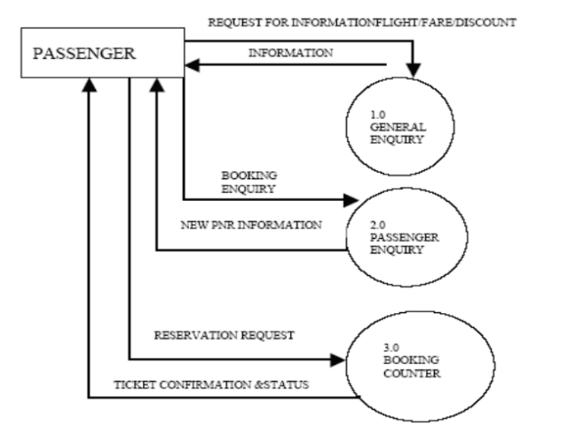Loop Testing is a type of software testing type that is performed to validate the loops. It is one of the type of Control Structure Testing. Loop testing is a white box testing technique and is used to test loops in the program. The objective of Loop Testing is:

* To fix the infinite loop repetition problem.
* To know the performance.
* To identify the loop initialization problems.
* To determine the uninitialized variables

1. Condition testing

In software testing, a test condition is a specification that a tester must adhere to when testing a software program. For test cases, a test condition is a collection of restrictions that might include features such as transactions, functions, or structural aspects in order to test the software application. If correct amount and bank number is given as input then only payment gateway should work.

